Video: https://nyti.ms/3yFWOnf

The Internet’s Final Frontier: Remote Amazon Tribes
Elon Musk’s Starlink has connected an isolated tribe to the outside world — and divided it from within.

As the speeches dragged on, eyes drifted to screens. Teenagers scrolled Instagram. One man texted his girlfriend. And men crowded around a phone streaming a soccer match while the group’s first female leader spoke.
Just about anywhere, a scene like this would be mundane. But this was happening in a remote Indigenous village in one of the most isolated stretches of the planet.
The Marubo people have long lived in communal huts scattered hundreds of miles along the Ituí River deep in the Amazon rainforest. They speak their own language, take ayahuasca to connect with forest spirits and trap spider monkeys to make soup or keep as pets.
They have preserved this way of life for hundreds of years through isolation — some villages can take a week to reach. But since September, the Marubo have had high-speed internet thanks to Elon Musk.

The 2,000-member tribe is one of hundreds across Brazil that are suddenly logging on with Starlink, the satellite-internet service from Space X, Mr. Musk’s private space company. Since its entry into Brazil in 2022, Starlink has swept across the world’s largest rainforest, bringing the web to one of the last offline places on Earth.
The New York Times traveled deep into the Amazon to visit Marubo villages to understand what happens when a tiny, closed civilization suddenly opens to the world.
Image
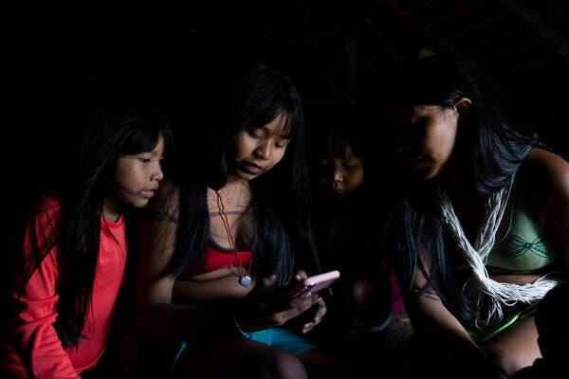
Many Marubo people have signed up for Facebook and Instagram accounts since Starlink arrived in their village.
Image
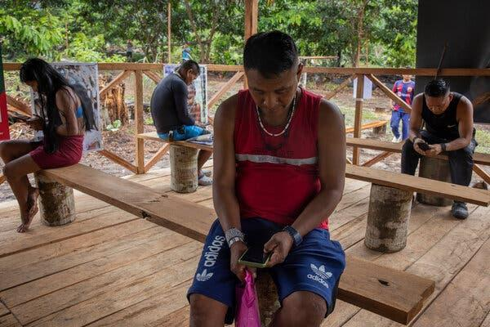
The Marubo people frequently use their phones, bought in the closest city, when the Starlink antenna is turned on in their village.
“When it arrived, everyone was happy,” said Tsainama Marubo, 73, sitting on the dirt floor of her village’s maloca, a 50-foot-tall hut where the Marubo sleep, cook and eat together. The internet brought clear benefits, like video chats with faraway loved ones and calls for help in emergencies. “But now, things have gotten worse,” she said.

She was kneading jenipapo berries to make a black body paint and wearing ropes of jewelry made from snail shells. Lately, the youth had become less interested in making such dyes and jewelry, she said. “Young people have gotten lazy because of the internet,” she said. “They’re learning the ways of the white people.”
Then she paused and added, “But please don’t take our internet away.”
The Marubo are struggling with the internet’s fundamental dilemma: It has become essential — at a cost.
After only nine months with Starlink, the Marubo are already grappling with the same challenges that have racked American households for years: teenagers glued to phones; group chats full of gossip; addictive social networks; online strangers; violent video games; scams; misinformation; and minors watching pornography.
Modern society has dealt with these issues over decades as the internet continued its relentless march. The Marubo and other Indigenous tribes, who have resisted modernity for generations, are now confronting the internet’s potential and peril all at once, while debating what it will mean for their identity and culture.
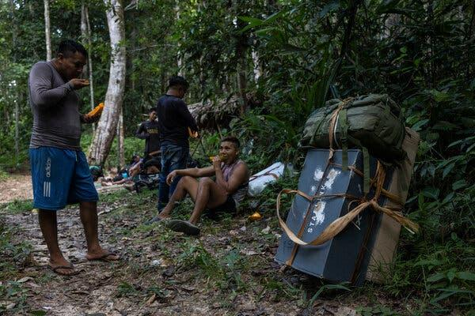
Marubo people carrying a Starlink satellite antenna stopped for a break to eat papaya.
Image
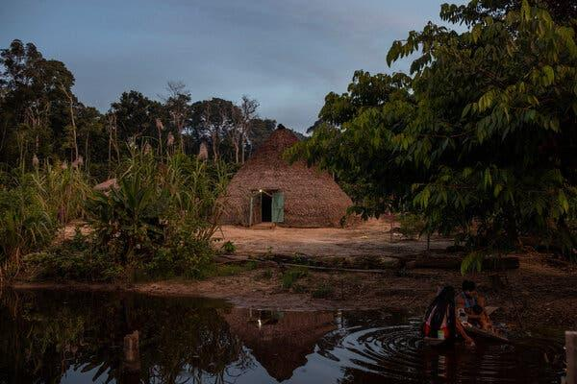
The Javari Valley Indigenous Territory, where the Marubo people live, is one of the most isolated places on Earth.
That debate has arrived now because of Starlink, which has quickly dominated the satellite-internet market worldwide by providing service once unthinkable in such remote areas. SpaceX has done so by launching 6,000 low-orbiting Starlink satellites — roughly 60 percent of all active spacecraft — to deliver speeds faster than many home internet connections to just about anywhere on Earth, including the Sahara, the Mongolian grasslands and tiny Pacific islands.
Business is soaring. Mr. Musk recently announced that Starlink had surpassed three million customers across 99 countries. Analysts estimate that annual sales are up roughly 80 percent from last year, to about $6.6 billion.

More on Brazil
- The Internet’s Final Frontier: Elon Musk’s Starlink, the satellite-internet service, has connected the Marubo people, an isolated tribe in the Amazon, to the outside world — and divided it from within.
- A Massive Fossil Donation: A gift of more than 1,100 Brazilian fossils aims to step up efforts to rebuild the country’s National Museum, which suffered major fire damage in 2018.
- New Political Players: Just a few months ago, the movement behind Brazil’s far-right former president, Jair Bolsonaro, was sputtering. Now he’s seeing a surge of momentum — with the help of Elon Musk and House Republicans.
- Clashing Climate Goals: The state-owned company Petrobras could soon be the world’s third-biggest oil producer, even as Brazil positions itself as a leader in the fight against climate change and deforestation in the Amazon.
Starlink’s rise has given Mr. Musk control of a technology that has become critical infrastructure in many parts of the globe. It is being used by troops in Ukraine, paramilitary forces in Sudan, Houthi rebels in Yemen, a hospital in Gaza and emergency responders across the world.
But perhaps Starlink’s most transformative effect is in areas once largely out of the internet’s reach, like the Amazon. There are now 66,000 active contracts in the Brazilian Amazon, touching 93 percent of the region’s legal municipalities. That has opened new job and education opportunities for those who live in the forest. It has also given illegal loggers and miners in the Amazon a new tool to communicate and evade authorities.

One Marubo leader, Enoque Marubo (all Marubo use the same surname), 40, said he immediately saw Starlink’s potential. After spending years outside the forest, he said he believed the internet could give his people new autonomy. With it, they could communicate better, inform themselves and tell their own stories.
Image
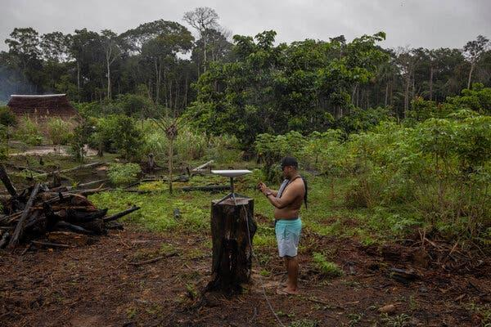
Enoque Marubo installing a Starlink satellite antenna in Manakieaway, a Marubo village.
Image
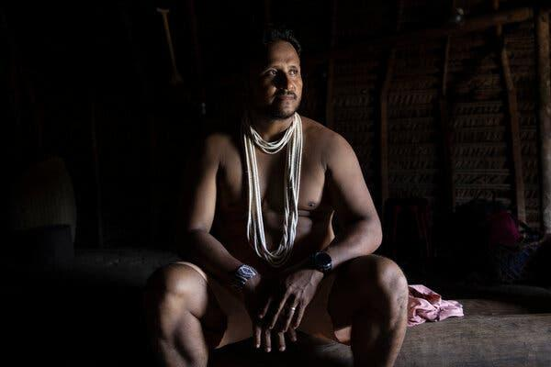
Enoque has split his life between the forest and the city, working at one point as a graphic designer for Coca-Cola.
Last year, he and a Brazilian activist recorded a 50-second video seeking help getting Starlink from potential benefactors. He wore his traditional Marubo headdress and sat in the maloca. A toddler wearing a necklace of animal teeth sat nearby.
They sent it off. Days later, they heard back from a woman in Oklahoma.

The Tribe
The Javari Valley Indigenous Territory is one of the most isolated places on Earth, a dense stretch of rainforest the size of Portugal with no roads and a maze of waterways. Nineteen of the 26 tribes in the Javari Valley live in full isolation, the highest concentration in the world.

The Marubo were once uncontacted, too, roaming the forest for hundreds of years, until rubber tappers arrived near the end of the 19th century. That led to decades of violence and disease — and the arrival of new customs and technology. The Marubo began wearing clothes. Some learned Portuguese. They swapped bows for firearms to hunt wild boar, and machetes for chain saws to clear plots for cassava.
One family in particular pushed this change. In the 1960s, Sebastião Marubo was one of the first Marubo to live outside the forest. When he returned, he brought another new technology: the boat motor. It cut trips from weeks to days.

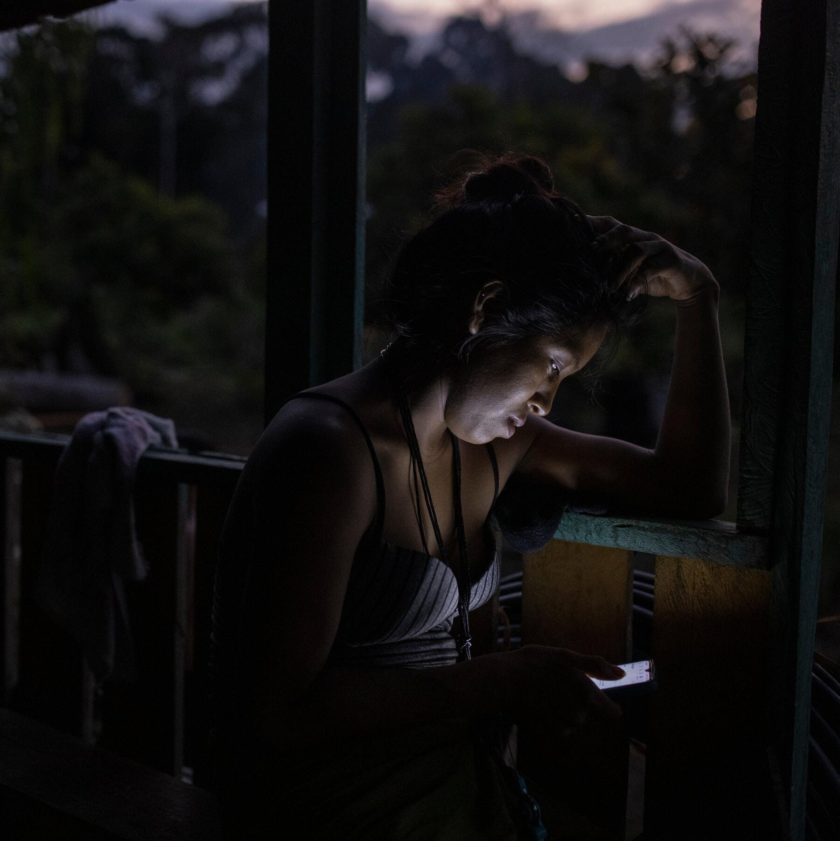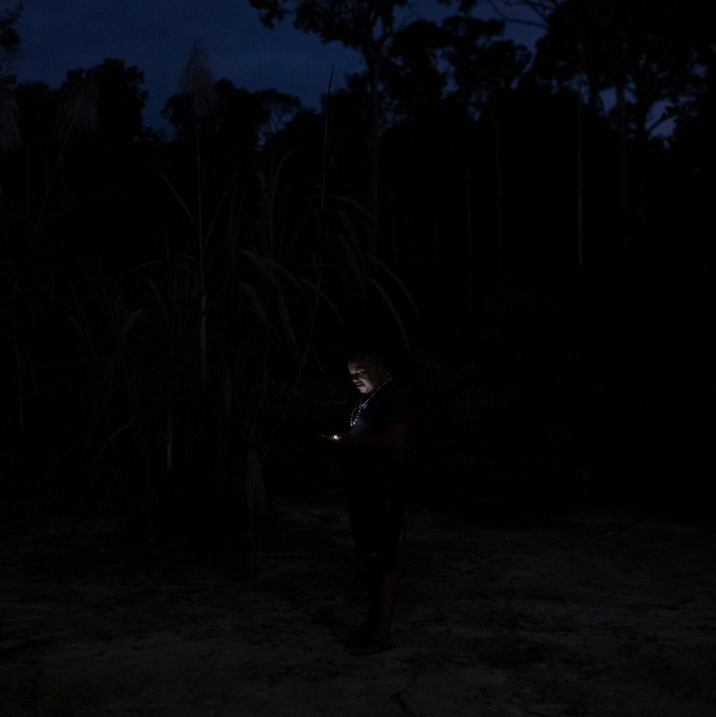

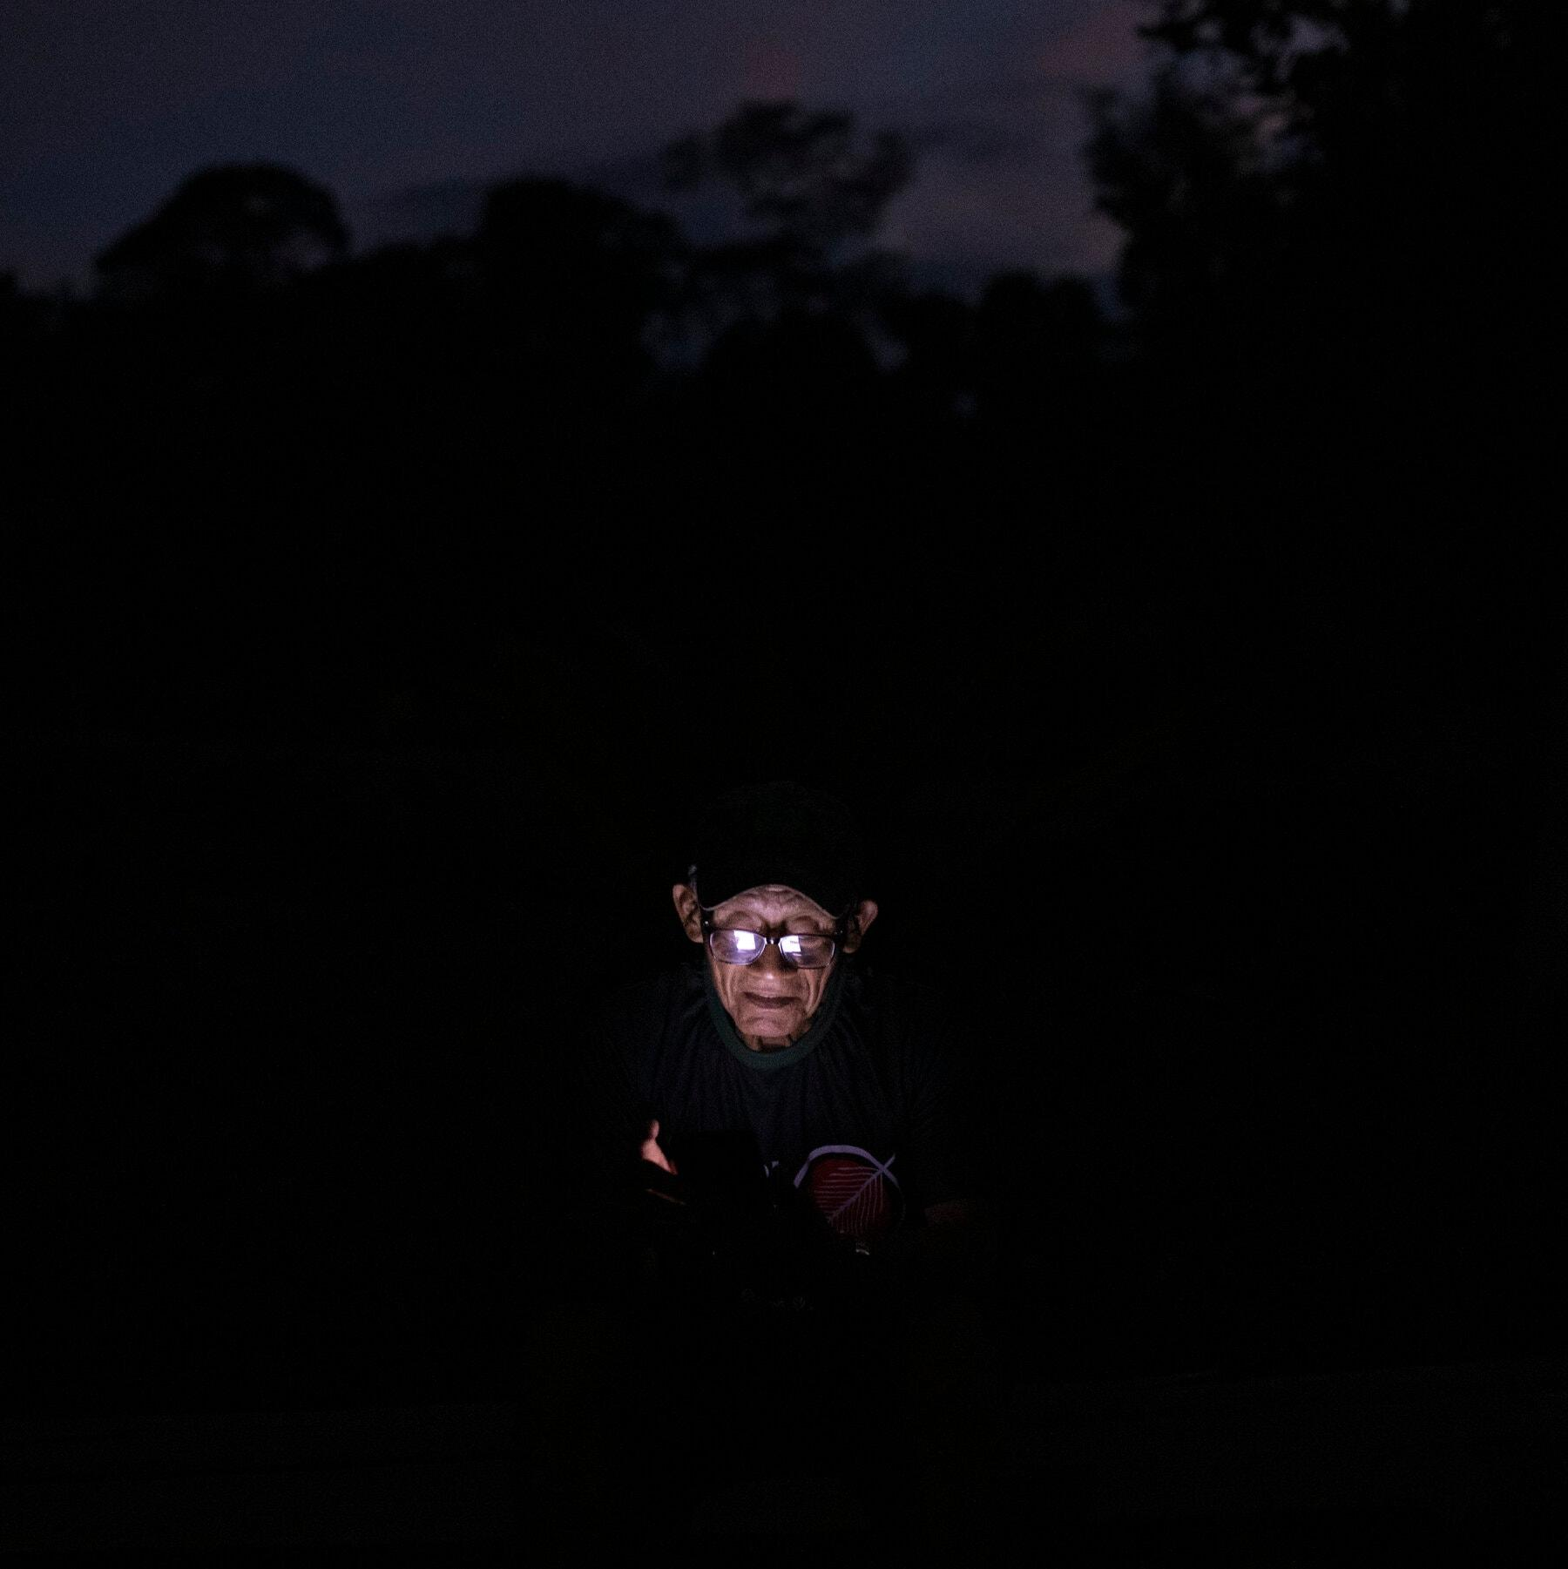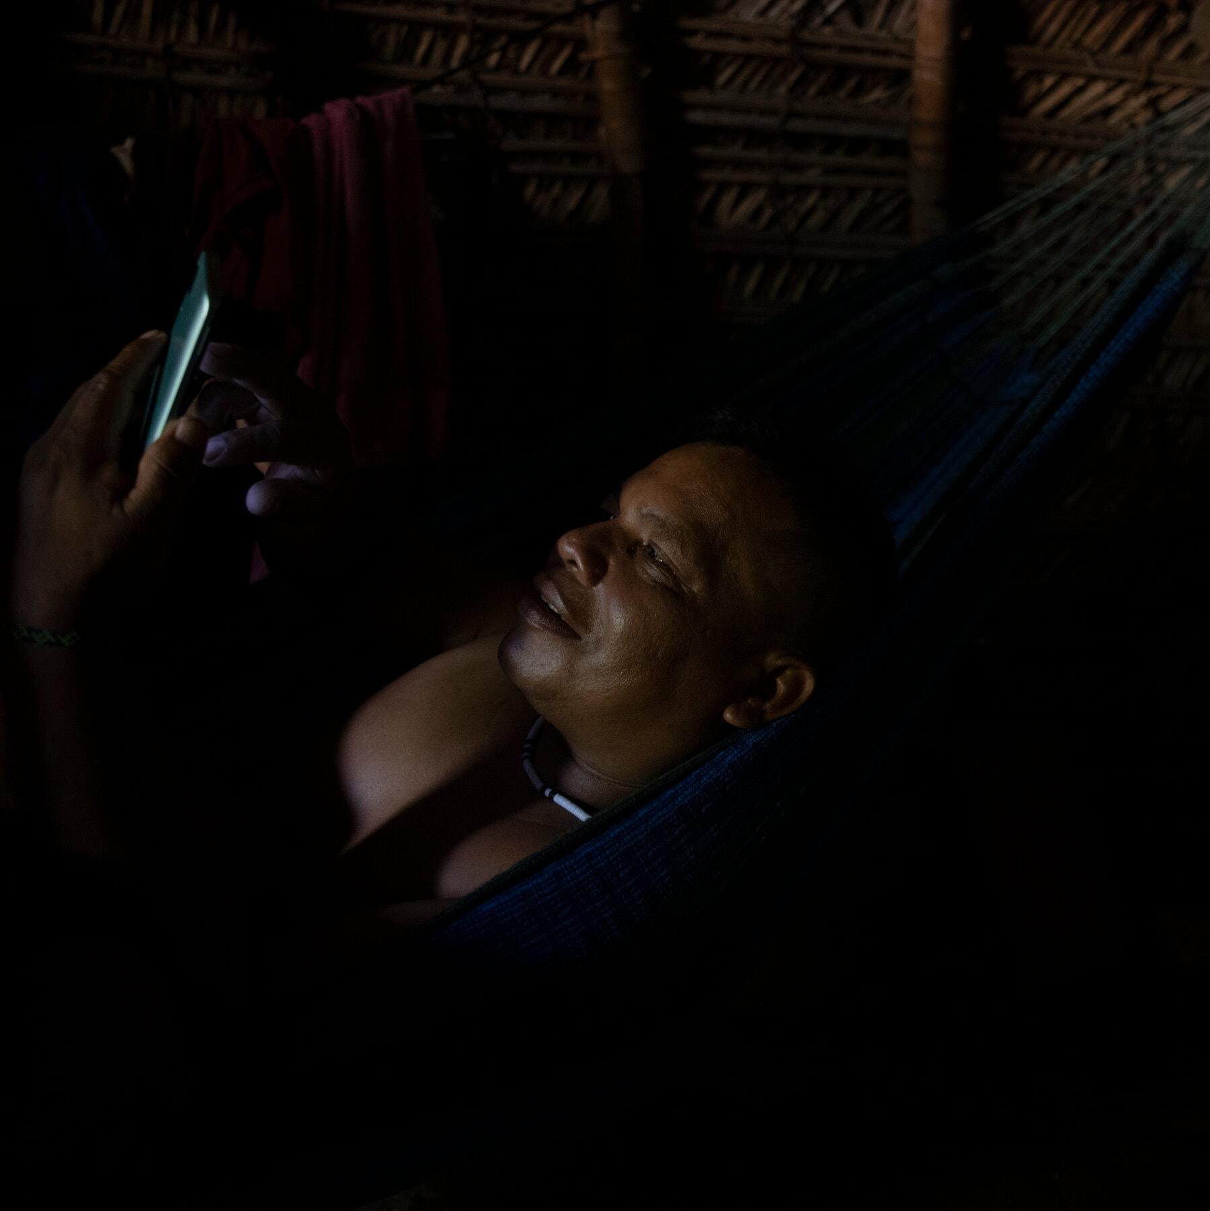

Villagers using their phones, connected to the internet via Starlink.
His son Enoque emerged as a leader of the next generation, eager to pull his tribe into the future. Enoque has split his life between the forest and the city, working at one point as a graphic designer for Coca-Cola. So when Marubo leaders became interested in getting internet connections, they went to him to ask how.
Enoque got his answer when Mr. Musk came to Brazil. In 2022, the SpaceX owner and Jair Bolsonaro, Brazil’s president at the time, announced Starlink’s arrival in front of a screen that said, “Connecting the Amazon.”

Enoque and Flora Dutra, a Brazilian activist who works with Indigenous tribes, sent letters to more than 100 members of Congress asking for Starlink. None responded.
Then early last year, Ms. Dutra saw an American woman speak at a space conference. Ms. Dutra checked the woman’s Facebook page and saw her posing outside SpaceX’s headquarters. “I knew she was the one,” she said.

The Benefactor
Allyson Reneau’s LinkedIn page describes her as a space consultant, keynote speaker, author, pilot, equestrian, humanitarian, chief executive, board director and mother of 11 biological children. In person, she says she makes most of her money coaching gymnastics and renting houses near Norman, Okla.
Her story is ripe for the “Today Show” — and, indeed, she has told it there. She enrolled in college at 47, got a master’s degree from Harvard Extension School at 55 and then became a traveling motivational speaker. Her social media shows her with children in Rwanda, on television in Pakistan and at conferences in South Africa.
The attention she has attracted has not always been well received. In 2021, she was interviewed on CNN and Fox News for “rescuing” an all-girls robotics team from Afghanistan during the Taliban takeover. But days later, lawyers for the robotics team told Ms. Reneau to stop taking credit for a rescue she had little to do with.

Ms. Reneau said she did not try to help people for fame. “Otherwise, I’d be telling you about all the projects I do all over the world,” she said in an interview. “It’s the look on the face, it’s the hope in the eyes. That’s the trophy.”
She said she had that perspective when she received a video from a stranger last year asking to help connect a remote Amazon tribe.
Image
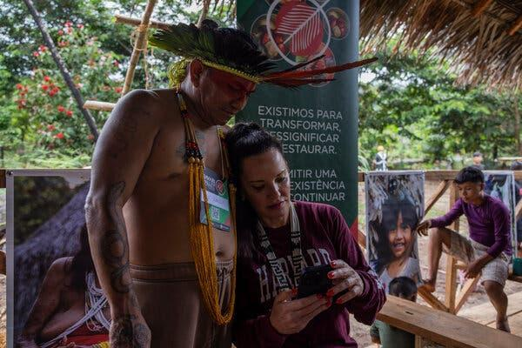
Allyson Reneau, right, has donated more than 20 Starlink antennas to the Marubo people. Here she is with Pajé Kaku of the Noke Kuī people, who was visiting a Marubo village.
Image
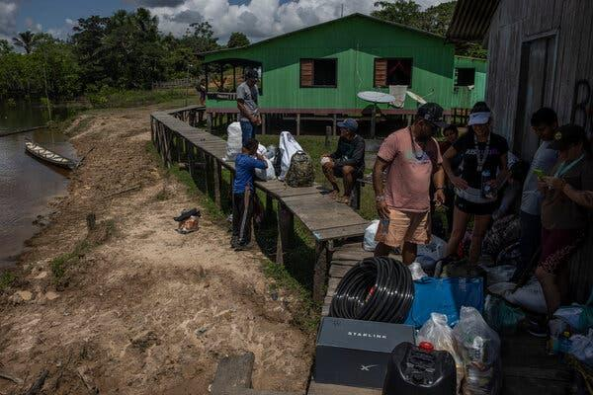
The Marubo people carried the Starlink antennas to their villages via multiple boat trips and miles of hiking.
She had never been to Brazil but thought the return on investment was high. Enoque was asking for 20 Starlink antennas, which would cost roughly $15,000, to transform life for his tribe.

“Do you remember Charlie Wilson?” Ms. Reneau asked me. She was referring to the Texas congressman who secured Stinger missiles that helped the Afghan mujahedeen defeat the Soviets in the 1980s — but that critics say also unintentionally gave rise to the Taliban.
Mr. Wilson changed that war with one weapon, she said. “I could see that this was similar,” she said. “One tool would change everything in their life. Health care, education, communication, protection of the forest.”
Ms. Reneau said she bought the antennas with her own money and donations from her children. Then she booked a flight to go help deliver them.

The Connection
The internet arrived on the backs of men. They trudged miles through the forest, barefoot or in flip-flops, carrying two antennas each.
Just behind were Enoque, Ms. Dutra, Ms. Reneau and a cameraman documenting her journey.
In the villages, they nailed the antennas to the tops of poles and plugged them into solar panels. The antennas then began connecting Starlink satellites to villagers’ phones. (Some Marubo already had phones, often bought with government welfare checks, to take photographs and communicate when in a city.)

The internet was an immediate sensation. “It changed the routine so much that it was detrimental,” Enoque admitted. “In the village, if you don’t hunt, fish and plant, you don’t eat.”
Image
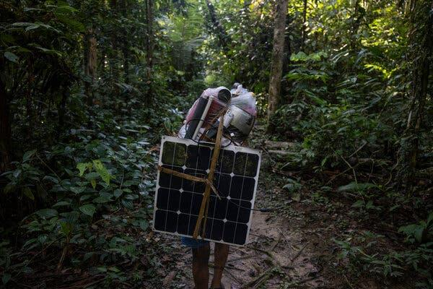
The Marubo people also carry solar panels to their villages, which are used to power the Starlink antennas.
Image
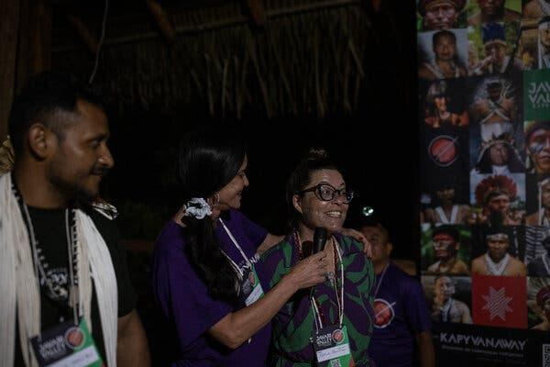
Flora Dutra, a Brazilian activist who works with Indigenous tribes, right, with Ms. Reneau and Enoque Marubo.
Leaders realized they needed limits. The internet would be switched on for only two hours in the morning, five hours in the evening, and all day Sunday.
During those windows, many Marubo are crouched over or reclined in hammocks on their phones. They spend lots of time on WhatsApp. There, leaders coordinate between villages and alert the authorities to health issues and environmental destruction. Marubo teachers share lessons with students in different villages. And everyone is in much closer contact with faraway family and friends.

To Enoque, the biggest benefit has been in emergencies. A venomous snake bite can require swift rescue by helicopter. Before the internet, the Marubo used amateur radio, relaying a message between several villages to reach the authorities. The internet made such calls instantaneous. “It’s already saved lives,” he said.

The Debate
In April, seven months after Starlink’s arrival, more than 200 Marubo gathered in a village for meetings.
Enoque brought a projector to show a video about bringing Starlink to the villages. As proceedings began, some leaders in the back of the audience spoke up. The internet should be turned off for the meetings, they said. “I don’t want people posting in the groups, taking my words out of context,” another said.
During the meetings, teenagers swiped through Kwai, a Chinese-owned social network. Young boys watched videos of the Brazilian soccer star Neymar Jr. And two 15-year-old girls said they chatted with strangers on Instagram. One said she now dreamed of traveling the world, while the other wants to be a dentist in São Paulo.

This new window to the outside world had left many in the tribe feeling torn.
“Some young people maintain our traditions,” said TamaSay Marubo, 42, the tribe’s first woman leader. “Others just want to spend the whole afternoon on their phones.”
Image
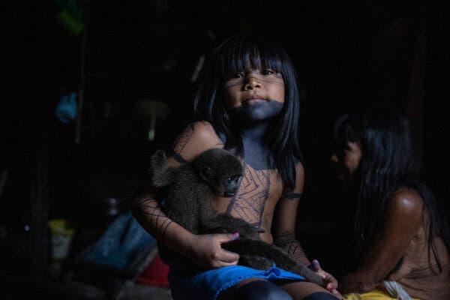
Voa Marubo with her pet monkey in the Manakieaway village.
Image
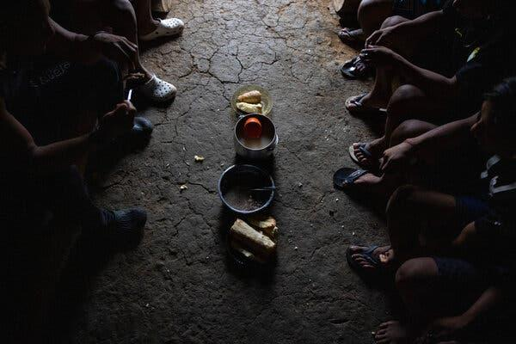
The Marubo eat from the same bowls placed on the ground, and their diet consists of cassava, wild boar, fish and banana porridge.
Kâipa Marubo, a father of three, said he was happy that the internet was helping educate his children. But he also was concerned about the first-person-shooter video games his two sons play. “I’m worried that they’re suddenly going to want to mimic them,” he said. He tried to delete the games, but believed his sons had other hidden apps.
Alfredo Marubo, leader of a Marubo association of villages, has emerged as the tribe’s most vocal critic of the internet. The Marubo pass down their history and culture orally, and he worries that knowledge will be lost. “Everyone is so connected that sometimes they don’t even talk to their own family,” he said.
He is most unsettled by the pornography. He said young men were sharing explicit videos in group chats, a stunning development for a culture that frowns on kissing in public. “We’re worried young people are going to want to try it,” he said of the graphic sex depicted in the videos. He said some leaders had told him they had already observed more aggressive sexual behavior from young men.

Alfredo and Enoque, as the heads of dueling Marubo associations, were already political rivals, but their disagreement over the internet has created a bitter dispute. After Ms. Dutra and Ms. Reneau delivered the antennas, Alfredo reported them for lacking proper permission from federal authorities to enter protected Indigenous territory. In turn, Ms. Dutra criticized Alfredo in interviews and Enoque said he was not welcome at the tribal meetings.

The Future
Ms. Dutra now has a goal to bring Starlink to hundreds more Indigenous groups across the Amazon, including Brazil’s largest remote tribe, the Yanomami.
Some Brazilian government officials and nongovernmental agencies said they worried that the internet was being rolled out to tribes too quickly, often without training on the dangers.
Ms. Dutra said Indigenous groups wanted and deserved connections. The criticism, she said, was part of a long tradition of outsiders telling the Indigenous how to live. “This is called ethnocentrism — the white man thinking they know what’s best,” she said.
Enoque and Ms. Dutra said they planned to provide internet training. No Marubo interviewed said they had yet received it.

In April, Ms. Reneau traveled back to the forest. At Enoque’s request, she bought four more antennas. Two were headed to the Korubo, a tribe of less than 150 people that was first contacted in 1996 and still has some members in full isolation.
Image
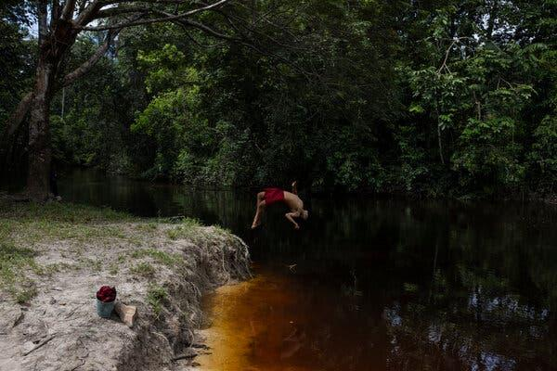
Mētsise Marubo playing in the river in the Kapyvanaway village of the Marubo people.
Image
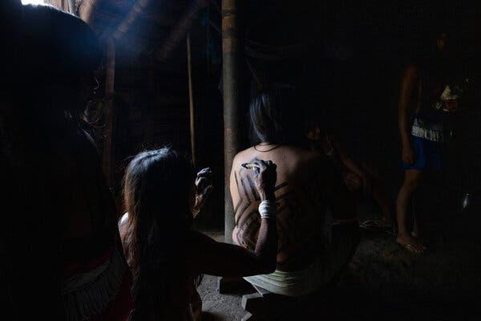
Marubo women applying traditional body paint made with fruit from the Amazon rainforest.
Sitting on a log, eating dried beef and boiled cassava served on the maloca’s dirt floor, Ms. Reneau said she recognized the internet was “a double-edged sword.” So when she posts on Facebook about bringing the Marubo internet, she said, she always stresses that a leader requested it.
“I don’t want people to think I’m bringing this in to force it on them,” she said. She added that she hoped they could “preserve the purity of this incredible culture because once it’s gone, it’s gone.”

Later at that same meal, Enoque’s father, Sebastião, said the tribe’s journey with the internet had been foretold.
Decades ago, the most respected Marubo shaman had visions of a hand-held device that could connect with the entire world. “It would be for the good of the people,” he said. “But in the end, it wouldn’t be.”
“In the end,” he added, “there would be war.”
His son sat on the log across from him, listening. “I think the internet will bring us much more benefit than harm,” Enoque said, “at least for now.”
Regardless, he added, going back was no longer an option.
“The leaders have been clear,” he said. “We can’t live without the internet.”
Image
